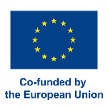
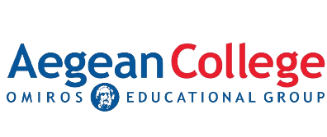
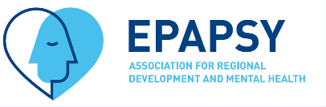
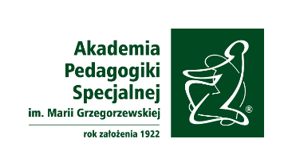
International seminar on knowledge and experience exchange:
The tools of migrants’ mental health support

Date 17.06.2024
Time 10.30-13.30
Venue: The Maria Grzegorzewska University; Szczęśliwicka 40, Warsaw, Poland

10.30-11.30 Dr. Valantis Papathanasiou, Greece: Workshop on Guided Self-Help Interventions for Reducing Psychological Distress among Female Ukrainian Refugees in Greece

11.30-11.40 Break

11.40-12.15 Dr Piotr Toczyski, Poland: EU4Health MESUR response on how to conduct mental health intervention based on iFightDepression tool

12.15-13.00 Dr Lidia Zabłocka-Żytka, Poland: Workshop on The power of communication. The BASIC Ph model in communication with migrants and care givers

13.00-13.30 Discussion and Q&A session

Dr. Papathanasiou Workshop description: “Guided Self-Help Interventions for Reducing Psychological Distress among Female Ukrainian Refugees in Greece”
The “Ukrainian Peer Support” (UPS) project, a crucial component of the “Community-based Interventions of Mental Health Care for Refugees and Asylum Seekers in Greece” programme, was implemented by EPAPSY in collaboration with UNHCR during 2022-2023. This initiative was aiming to provide essential psychosocial support to female Ukrainian refugees who have been displaced to Greece due to the ongoing conflict in their homeland.
During this workshop, peer-led interventions that form the backbone of the project will be presented. These interventions were designed to offer guided self-help strategies, empowering Ukrainian refugee women by leveraging the shared experiences and insights of peers who have undergone similar challenges. The workshop will detail the methodologies employed in the project, the structure of the peer support groups, and the specific techniques used to address common psychological and social issues faced by the refugees.
Participants will gain an understanding of the outcomes achieved through these interventions, including improvements in mental health, social integration, and overall well-being of the participants. The discussion will also cover the challenges encountered during the implementation and the lessons learned, providing a comprehensive overview of the project’s impact and its potential as a model for future psychosocial support initiatives in refugee contexts.
We invite mental health professionals, social workers, and anyone interested in refugee support to join this workshop to explore the effectiveness of guided self-help interventions and to discuss the critical role of community-based approaches in mental health care for refugees.

Invited Speaker
Dr. Valantis Papathanasiou holds a PhD in Social Psychology from Aix-Marseille Université. He also earned a Master’s degree in Sociology from the École des Hautes Études en Sciences Sociales (EHESS) in Paris. During his postgraduate studies, he was affiliated with the Centre for Research on Medicine, Science, Health, Mental Health, and Society (CERMES3). Between 2017 and 2019, Dr. Papathanasiou served as a Postdoctoral Fellow at the Department of Psychology at Panteion University of Social and Political Sciences in Athens, supported by a scholarship from the State Scholarships Foundation (IKY). Dr. Papathanasiou has held high positions in public administration, serving as the Deputy Manager of the University Hospital of Patras and as President of the National Center for Social Solidarity (EKKA) in Greece. Since 2023, he has been the Deputy Secretary of the Social Inclusion and Cohesion Sector of PASOK, the social democratic party of Greece. Dr. Papathanasiou has extensive teaching experience, having lectured on Psychology and Sociology at several Greek universities. He recently led the largest mental health care programme for refugees and asylum seekers in Greece, implemented by the Association for Regional Development and Mental Health (EPAPSY) in partnership with UNHCR, the UN Refugee Agency. He is also the founder of the Psychosocial Support Centre for Refugees (PSCR) in Athens. Currently, he is the Programme Director of the MSc in Human Rights and Migration Studies, offered by Aegean College in collaboration with the University of Essex. He is an active member of many scientific societies, and his research has been published in peer-reviewed journals and presented at numerous European and international conferences.
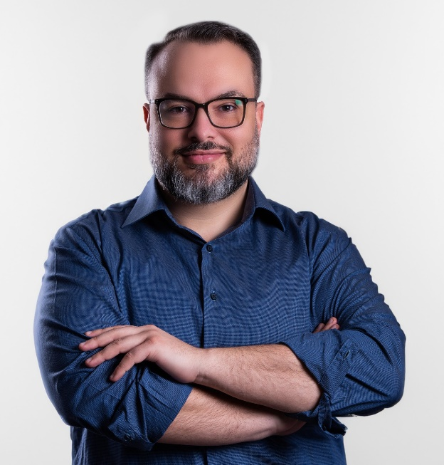

Dr Lidia Zabłocka-Żytka – clinical psychologist, psychotherapist, academic teacher. For 20 years she has been working in The Maria Grzegorzewska University in the Department of Psychology as well as a psychotherapeutist in public and private clinics. She is an active member of ENTER Mental Health Network and take part in international projects on mental health promotion and disorder prevention f.e. CAMILLE, ERICA, I_AM projects. As a researcher she is interested in mental health factors as well as mental health programs. She is an author and coauthor of publications on mental health, mental health promotion and methods of psychological support.

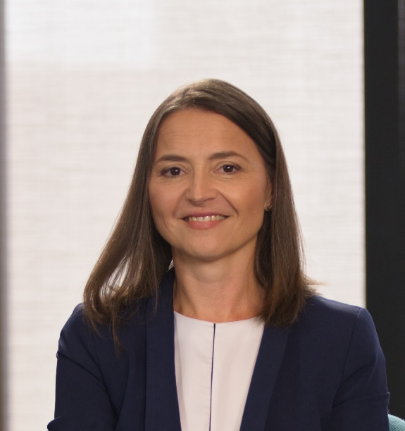

Piotr Toczyski, MPsych, PhD, is a psychologist involved in several EU-funded community-based interventions for public mental health (EAAD-Best alliances against depression) and digital mental health tools (iFightDepression guided workshops). His current focus is EU-recognized programme of Mental Health Support for Ukrainian Refugees in Bulgaria, Estonia, Germany, Greece, Hungary and Poland.
