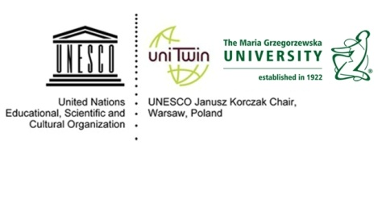

10th International Summer School

The contemporary problems of children and childhood in multicultural societies - theory, research, praxis

15 – 24 September 2016
organised by
the UNESCO Janusz Korczak Chair at the Maria Grzegorzewska Academy of Special Education
in cooperation with the Faculty of Education in Osijek (J.J.Strossmayer University, Croatia),
The Polish National Commission for UNESCO
and Bureau for Academic Recognition and International Exchange – CEEPUS Programme

Participant data

First and middle names:

Family name:

Nationality:

Date and place of birth:

Passport number:

Permanent address and zip code:

E-mail:

The name of full address of the University:

Work position:

University degree; Diplomas:
Research area:

References - List two persons /titles, e-mail/ who can provide information on qualifications of candidate

1.……………………………………………………………………………………………………………………………..

2. ……………………………………………………………………………………………………………………………..
The “Participant data” duly completed should be sent electronically,
no later than 20 march 2016 to: unescochair@aps.edu.pl

